**KRISHNA ENGINERING COLLEGE** 

(Approved by AICTE & Affiliated to Dr. APJ Abdul Kalam Technical University (Formerly UPTU), Lucknow)

**Department of**

**Computer Science and Engineering (Artificial Intelligence) Data Structure using C Lab (KCS351)**

**Exercise-7: Write C Programs to illustrate the concept of Queue.**

**List of Experiments:**

**In Lab work:**

1. Write a program in C for the implementation of Queue using Array.

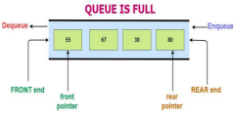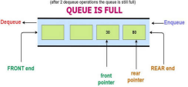2. Write a program in C for the implementation of Circular Queue using Array.

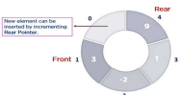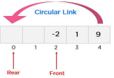3. Write a program in C for the implementation of Queue using Linked List.

**Take Away:**

4. Write a program in C for the implementation of Priority Queue using Array.

5. Write a program in C for the implementation of Double Ended Queue using Array. **Applications of Queues:**

**Printer queue:** Various programs place print jobs there, and usually, there is only one printer, which then processes the jobs one after the other.

**Processing of HTTP requests in a web server:** A web server usually works with a thread pool for processing requests simultaneously. If more requests come in than can be processed at the same time, the thread pool is at capacity. Additional requests are then queued and processed in first-in-first-out order as soon as more threads are available. **Job Scheduling**

Reference: https://www.happycoders.eu/algorithms/queue-data-structure/

https://simplesnippets.tech/circular-queue-data-structure-c-program-to-implement-circular-queue-operations/